Vertical Scalability
- Vertical scaling mean increasing the size, the spec of the instace
- Commonly used for non distributed system such as DATABASE
- RDS, Elastic Cache are services that can scale vertically
- There’s usually a limit to how much you can vertically scale (hardware limit, fund limit)

Horizontal Scalability
- Horizontal Scaling means increasing the number of instances/ systems for your application
- Horizontal scaling implies distributed systems
- Very common for web apps / modern apps
- It’s easy to do horizontal scale thanks to services like Amazon EC2

High Availability(HA)
- HA usually goes with Horizontal Scaling
- HA means running your app/system in at least 2 data centers or AZ
- The goal of HA is to survive data center loss
- HA can be passive (for RDS Multi AZ)
- HA can be active(for horizontal scaling)

ELASTIC LOAD BALANCING
Load balancers are server that forward traffic to multiple servers (EC2 instances) downstream. Load balancing main goal to distributed traffic to different Ec2 instances(servers) to avoid server overload due to large number of connection at the same time, allow high availability
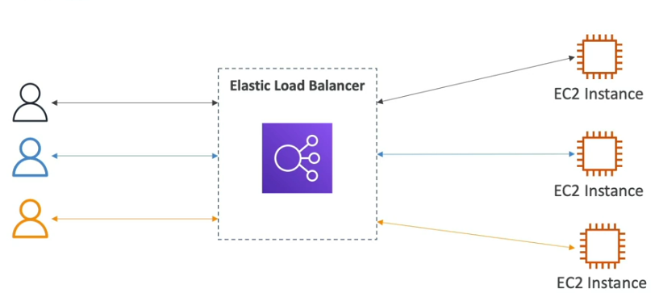
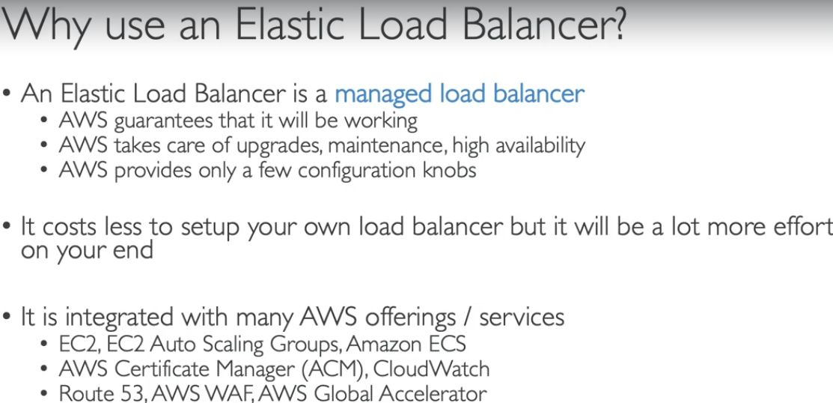
- Health Checks: is a way your ELB check whether the instance working to send or not to send traffic toward that instance

Types of load balancer on AWS
- AWS has 4 kind of managed Load Balancers
- Classic Load Balancer(AWS not recommended)
- Application Load Balancer(V2 – new gen) – 2016 –ALB: HTTP, HTTPS, WEBSOCKET
- Network Load Balancer(V2 – new gen) – 2017 – NLB: TCP, TLS, UDP
- Gateway Load Balancer – 2020- GWLB: Operate at 3 layers (Network layer) – IP protocol

Load Balancer Security Groups:
EC2 only allow traffic if it from a load balancer security group
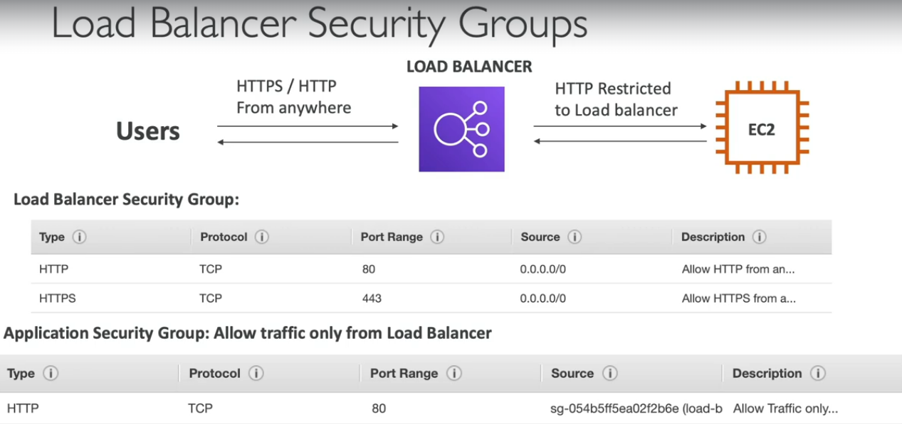

Application Load Balancer - ALB (v2)
ALB is Layer 7(HTTP)
Load balancing to multiple apps across machines (target groups)
Load balancing to multiple apps on the same machine(containers)
Support for HTTP/2 and WebSocket
Support redirect (fromm HTTP to HTTPS)
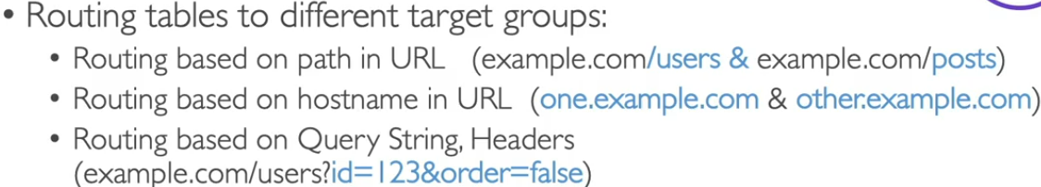
ALB are great fit for micro services & container-based application (Docker & Amazon Elastic Container Service)
Has a port mapping feature to redirect to a dynamic port in ECS
ALB Target Groups:
- Ec2 instances(can be managed by Auto Scaling Group) – HTTP
- EC2 tasks (managed by ECS itself) – HTTP
- Lambda Functions – HTTP request is translated into a JSOn event
- IP Addresses – must be private IPs
- ALB can route to multiple target groups
- Good to know:
  - Fixed hostname
  - Application server don’t see the IP of client directly
How to create Load Balancer for instances
Ex: Create an instance with 2 instances in Number of instances
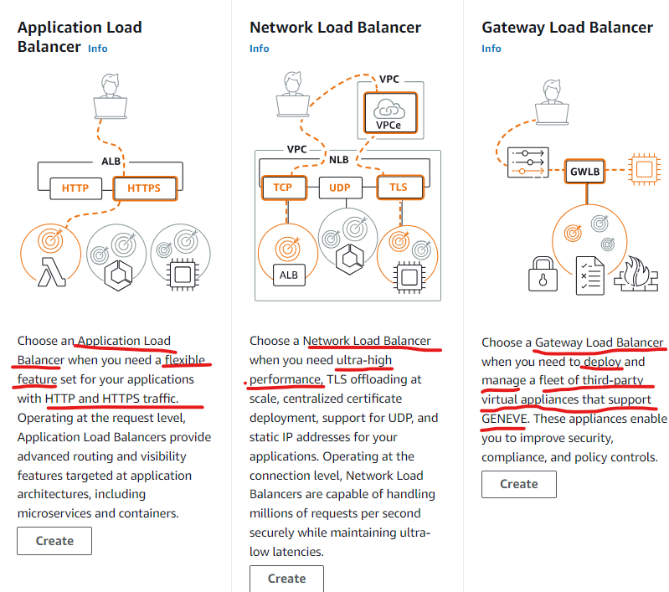
EC2 > Load Balancer > Choose the right type of ALB this case Application Load Balancer > Name > Scheme > Load balancer IP address type > IPv4 > Network mapping > VPC > Availability Zone> Security Groups > Listeners and routing => Create new Target group to group all the instances you want to Load balancing
Create Target group:
Target type: Instances
Target group name
Protocol: HTTP port 80
IP address type: IPv4
VPC
Protocol version: HTTP1
Health checks: protocol: HTTP
Finally press Next button
Select the target group you want to load balancing > Include as pending below > Press Create target group
Back to Load balancer then select target group
Finally Create load balancer

Application Load Balancer part 2 – Set IP only accessible through Load Balancer DNS name
Go to EC2 instance > Security group section > Modify Inbound rule of that security group that only allow HTTP through Security group of Load Balancer’s security group. After this only Load balancer DNS name able to access
Ex: demoalb-139657213.ap-southeast-1.elb.amazonaws.com
This to tighten security not allow user directly access to EC2 ip but they have to go through Load Balancer DNS name
Note: This mean EC2 instances must have different security group from Load Balancer

Set rule for Load Balancer
Select Load Balancer you want to add rule > Select the rule you want to change > Add rule
Add rule steps:
Step 1: Set rule name
Step 2: Set conditions
- Rule condition types:
- Host header: A host header is a case insensitive domain name that consists of labels separated by dots. There are 1-63 characters allowed per label. Labels can't begin or end with hyphens. Hyphens and underscores aren't allowed after the final dot
- Path: define a specific path when this path is being called logic code user define will be triggered
- HTTP request method: This condition routes traffic based on the HTTP method (e.g., GET, POST, PUT, DELETE) used in the request.
- Source IP: Specify from where the data or request is coming. If your client is behind a proxy, enter the IP address of the proxy.
- HTTP header name: Rule will assess requests containing this header to confirm matching values
- Query String: Route requests based on key:value pairs or values in the query string. Not case sensitive
In this example we choose path ‘/error’ and when call Load balancer DNS name ip/error with return error message page as a result.
Step 3: Define rule actions
- Action types
- Forward to target groups
- Redirect to URl
- Return fixed response
In this case we will use Return fixed response:
Response code: 404, Content type: text/plain
Response body: Not found, custom error!
Step 4: Define rule priority
Priority value must be around 1-50000
We choose 5 for DemoRule
Step: Review and Create
Press Create then we’re DONE
Now when call Load Balancer DNS name + “/error” will return message “Not found, custom error!”
demoalb-139657213.ap-southeast-1.elb.amazonaws.com/error

Network Load Balancer (layer 4)
- NLB allows:
- Forward TCP & UDP traffic to your instances
- Handle millions of request per seconds
- Ultra-low latency
- NLB has one static IP per AZ, and support assigning Elastic IP
- NLB are used for extreme performance , TCP of UDP traffic
- Not included in AWS free tier
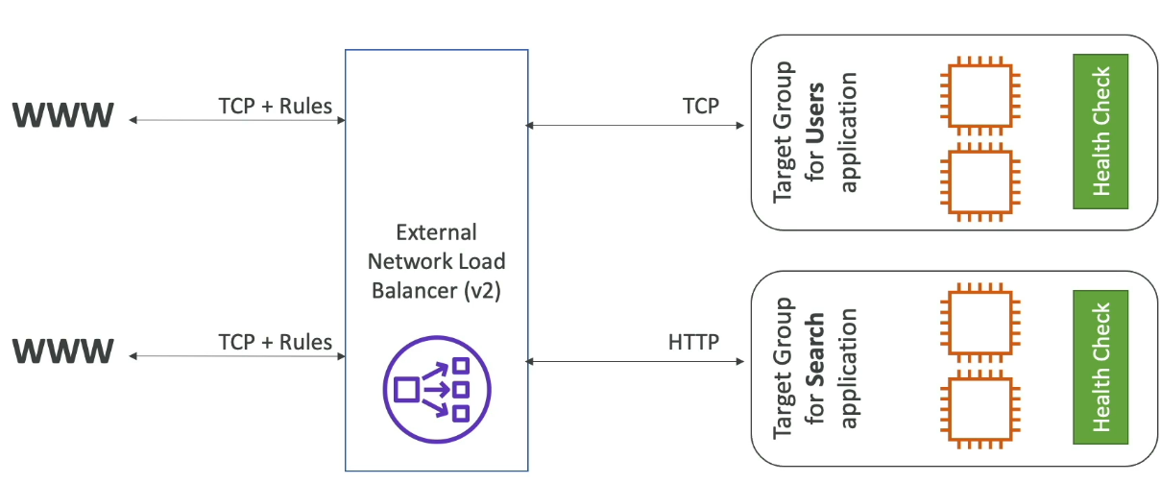
Network Load Balancer – Target Groups
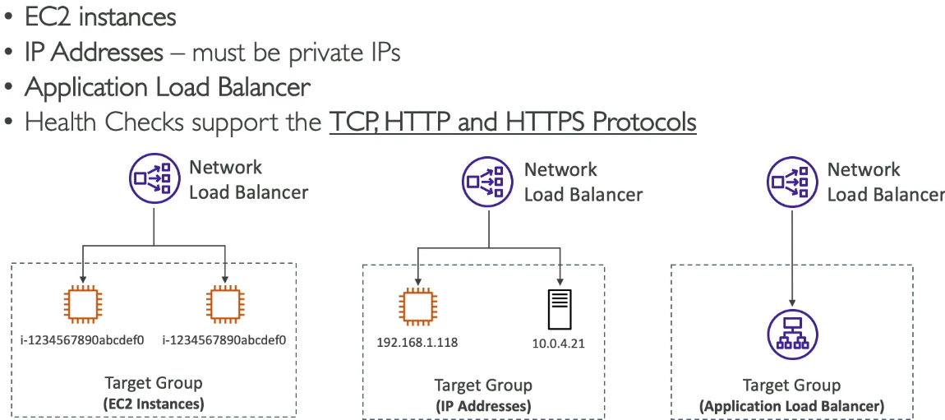
How to create Network Load Balancer for your EC2 instances
Load Balancer > Network Load Balancer > IpV4> VPC with multi-AZ
Security groups: Load balancer Security group allow all HTTP port 80. Remember to allow HTTP from NLB’s security group for the EC2 instances you put in NLB
Listener and Routing:
Target group : Instance > Protocol port 80
Health Check: HTTP
Unhealthy threshold: 2
Include as Pending below > Create Target group
Back to creating NLB > Select the Target group you just created
Finally press Create load balancer

Gateway Load Balancer
Deploy, scale and manage a fleet of 3rd party network virtual appliances in AWS
Example: Firewalls, Detection and Prevention System
Operate at Layer 3 (Network Layer) – IP Packets
Combines the following functions:
- Transparent Network Gateway – single entry/exit for all traffic
- Load Balancer – distributes traffic to your virtual appliances
Use the GENEVE protocol on port 6081
GLB – Target Gorups
- EC2 Instances
- IP Addresses – must be private IPs

Sticky Session (Session Affinity)
- You manually predefined or set a client always to be redirected to the same instance you want.
- This work for Classic Load Balancer, Application Load Balancer, Network Load Balancer
- The “cookie” used for stickiness has an expiration date you control
- Use case: make sure user doesn’t lose their session data
- Enabling stickiness may bring imbalance to the load over the backend EC2 instances
Sticky Session – Cookie Names
- Application-based Cookies:
- Custom cookie
- Application cookie
- Duration-based Cookies
How to set Sticky Session for Target Group of Load Balancer
Select the Target group you want > Actions > Edit target group attributes
Select “Stickiness” > Select Turn on Stickiness > Select the type of Cookie

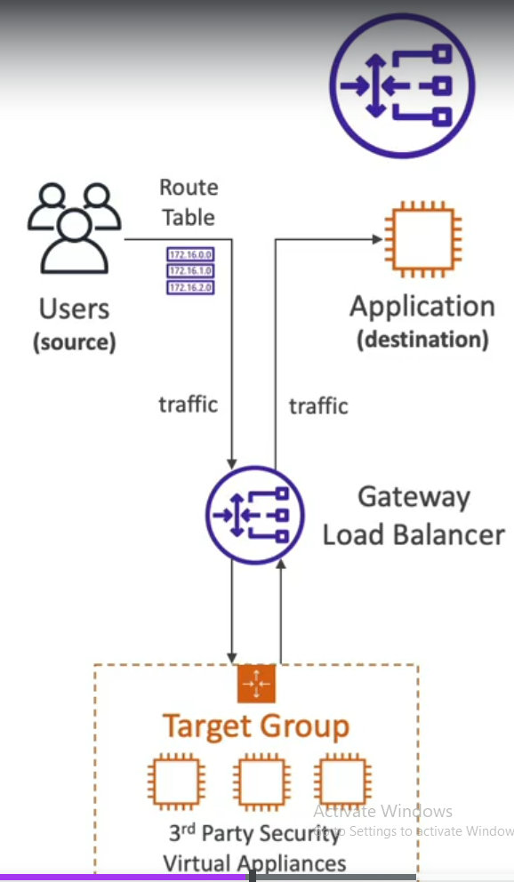
Gateway Load Balancer flow:
Route Table go through GLB then GLB spread it throughout the Target Group of Ec2 instances and 3rd Party Security Virtual Appliances will analyze all the traffic going through GLB
Next if pass it will send traffics back to GLB then GLB will forwards all the traffics to your application (destination)

Cross-Zone Load Balancing
Basically means the Load Balancer will distribute the traffic evenly across all AZ in the load balancer instead of distribute evenly within each AZ create an imbalance traffic distribution between different AZ
- Application Load Balancer: enable by default and FREE charge
- Network Load Balancer: Disabled by default and You PAY CHARGES for inter AZ data if enabled
- Classic Load Balancer: Disabled by default, FREE CHARGE
To check whether if Crozz-zone load balancing is Enable: inside the Load balancer detail > Attributes tab
Press Edit in Attributes tab of Load Balancer to enable/disable Cross-zone Load balancing.

SSL/TLS – Basics
- SSL certificate allow traffic between clients and load balancer to be encrypted in transit (in-flight encryption)
- Encrypt between Network and Client
- SSL refer to Secure Sockets Layer used to encrypt connections
- TLS refers to Transport Layer Security which is a newer and currently most popular version
- Public SSL certificates are issued by Certificate Authorities (CA)
- Ex: Comodo, GoDaddy, GlobalSin, DigitCert,….
- SSL certificates have an expiration data and must be renewed

Load Balancer – SSL Certificates
Users Send HTTPS (HTTP with encrypted SSL) over WWW to Load Balancer
Load Balancer Send HTTP over private VPC to EC2 Instance
- Load balancer uses an X.509 certificate (SSL/TLS server certificate)
- You can manage certificates using ACM (AWS Certificate Manager)
- You can create upload your own certificates
- HTTPS listener:
  - You must specify default certificate
  - You can add an optional list of certs to support multiple domains
  - Clients can use SNI (Server Name Indication) to specify the hostname they reach
  - Ability to specify a security policy to support older version of SSL/ TLS (legacy clients)

SNI – Server Name Indication – SNI
- SNI solves the problem of loading multiple SSL certs onto 1 web server (to serve multiple webs)
- Its newer protocol, requires the client to indicate the hostname of the target server in the initial SSL handshake
- The server will then find the correct cert or return the default one.
- Note:
  - Only work for ALB and NLB
  - Does not work for CLB

Elastic Load Balancers – SSL Certificates 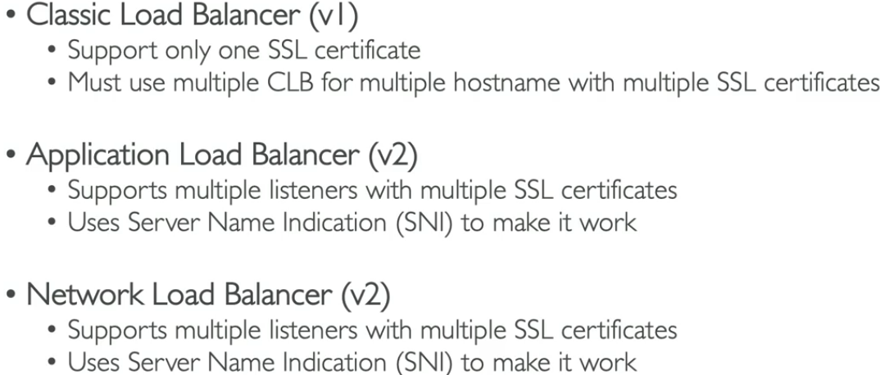
To add HTTPS (HTTP with encrypted SSL) to your Local Balancer:
In Load Balancer > Add listener > Protocol : HTTPS Port 443
Routing actions: Forward to target group
Target group that containing all the EC2 instances with load balancer
Security policy:
Policy name: ELBSecurityPolicy-LTS-13-1-2-2021-06
Certificate source: From ACM or From IAM or Import certificate
In this choose from ACM Amazon Certificate Manager
Then create a Private Hosted Zone in “Route 53” for testing
Then create ACM with this Route 53’s domain name
Back to Add listener add the ACM that AWS had validated then Create Listener

Connection Draining
Give the user time to complete “in-flight requests” while the instance is de-registering or unhealthy
Stop sending new requests to EC2 which is de-registering
Last between 1 to 3600 seconds
Can be disabled by set value to 0
Set to a low value if your requests are short

Auto Scaling Group
- The goal of Auto Scaling Group are to:
- Scale out (add EC2 instances) to match an increase load requirements
- Scale in( remove EC2 instances) to match a decrease load
- Ensure we have minimum and maximum number of EC2 instances running
- Automatically register new instances to a load balancer
- Re-create an EC2 instance in a case previous one is terminated
- ASG are free, you only pay for the underlying EC2 instances
- How it works:
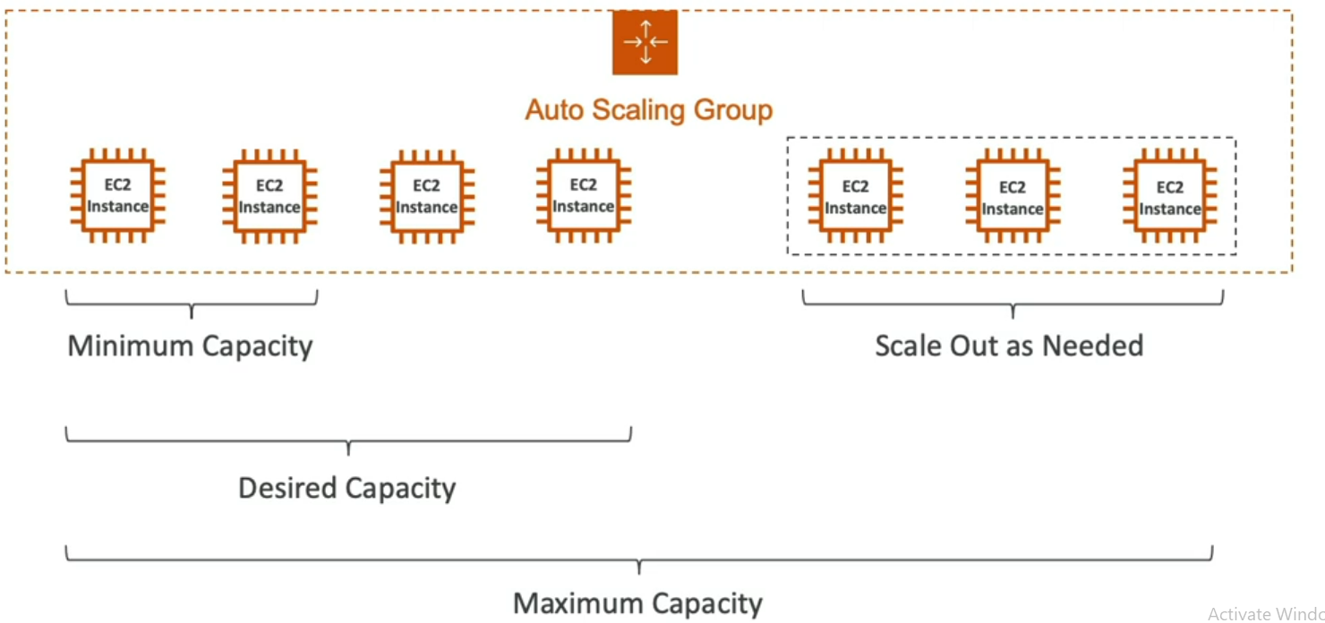
Since Elastic Load Balancer (ELB) can work with ASG, Load Balancer will balance out the traffic and distribute it evenly across instances that were removed or added by ASB.

Auto Scaling Group Attributes
- A Launch Template:
  - AMI + Instance type
  - EC2 User Data
  - EBS Volumes
  - Security Groups
  - SSH key pair
  - IAM Roles for your instances
  - Network + Subnet information
  - Load Balancer information
- Min size/ Max size/ Initial capacity
- Scaling Policies

Auto Scaling – CloudWatch Alarms & Scaling
It is possible to trigger an ASG based on CloudWatch alamrs
An alarm monitor a metric( average CPU usage, memory usage,…)
What trigger alarm: CPU usage %, memories usage %, disk usage %
Based on the alarm:
- We can create scale-out policies(increase the number of instances)
- We can create scale-in policies(Decrease the number of isntances)
Auto Scaling Group – Hands on
Step 1: Create Launch Template
Input Launch template name, description
Select OS
Ex: Amazon Linux, Instance type: t2.micro (free tier)
Select Key pair
Network settings
Select Subnet with the AZ you want
Select Security group
Storage: 8GiB, EBS, SSD
Advance Details:
User Data:
#!/bin/bash
# Use this for your user data (script from top to bottom)
# install httpd (Linux 2 version)
yum update -y
yum install -y httpd
systemctl start httpd
systemctl enable httpd
echo "<h1>Hello World from $(hostname -f)</h1>" > /var/www/html/index.html
Step 2: Create Auto Scaling Group
Click Create Auto Scaling Group, input Auto Scaling group name
Select Launch Template you just created, select version. Press NEXT
Select subnets and AZ you want. Press Next
Step 3: Select Load Balancing option
There are 3 option: No load balancer, Attach to an existing load balancer, Attach to a new load balancer
In this case choose: Attach to existing load balancer you created Application Load Balancer before
Then Choose target group
Health Checks: EC2 health checks always enabled, and we enable ELB health checks too
Optional : Enable group metrics collection within CloudWatch we not enable it this time
Step 4: Configure group size and scaling policies
Select Group size, Min desired capacity, Max desired capacity
Select NO scaling policies this time
Step 5: Add notifications (Optional)
Step 6: Add tags (Optional)
Step 7: Review
Finally press Create Auto Scaling Group
Result: 1 new EC2 instance will be created, New log in Auto Scaling Group > Activity tab
Ex:
Status | Description | Cause | Start time | End time
Successful | Launching a new EC2 instance: i-06b58cef6492d0a15 | At 2024-10-18T04:46:45Z a user request created an AutoScalingGroup changing the desired capacity from 0 to 1. At 2024-10-18T04:46:50Z an instance was started in response to a difference between desired and actual capacity, increasing the capacity from 0 to 1. | 2024 October 18, 11:46:52 AM +07:00 | 2024 October 18, 11:46:58 AM +07:00

Auto Scaling Groups – Scaling Policies
- Dynamic Scaling
- Target Tracking Scaling: simple to set up. Ex: I want the average ASG CPU to stay around 40%
- Simple/ Step Scaling:
  - When a CloudWatch alarm is triggered (ex CPU > 70%) then add 2 units
  - When a CloudWatch alarm is triggered (ex CPU <40%) then remove 1 unit
- Scheduled Scaling
- Anticipate a scaling based on known usage patterns
- Ex: increase the min capacity to 10 at 5PM on Fridays because many users access the domain around this time
Good metrics to scale on
- CPU Utilization: Average CPU utilization across your instances
- RequestCountPerTarget: to make sure the number of requests per EC2 instances is stable
- Average Network In/Out
- Any custom metric (that you push using CloudWatch)

Auto Scaling Groups – Scaling Cooldowns
- After a scaling activity happens, you are in the cool down period (default 300 seconds)
- During cool down period the ASH will not launch or terminate additional instances
- Advice: Use a ready-to-use AMI to reduce configuration time in order to be serving request fasters and reduce cool down period

ASG – Scaling Policies hands on
In Auto Scaling Groups:
Automatic Scaling will have:
- Scheduled actions: To schedule an auto-scaling action with predefined desired capacity, min and max instances set to trigger when it reach the specific scheduled time.
- Predictive Scaling policies: Machine learning driven scaling, your ASG will scaling based on the predefined metric you set like CPU usage
- Dynamic Scaling Policy:
  - Simple Scaling: Create CloudWatch alarm then set the “Take the action” like add/remove/set to capacity units based percent of group.
  - Step scaling: Add/remove/set to capacity units in a sequent step-by-step
  - Target tracking scaling: will have metric type to trigger scaling based on “Target value” ex: 10%, 50% of Average CPU utilization/ Average network in(bytes)/ Average network out(bytes)/ Application Load Balancer request count per target
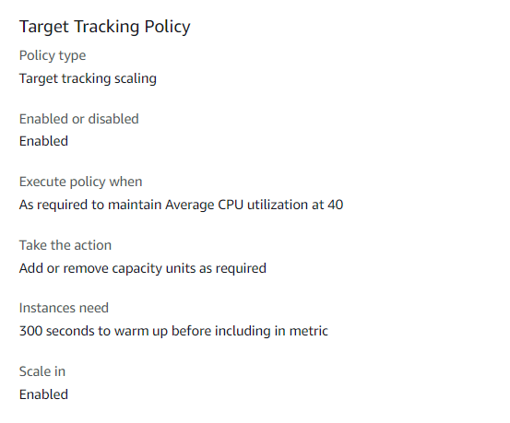
Test scenario: Install app to push your EC2 instance CPU usage to 100% to test the execute policy when Average CPU utilization at 40 is triggered or not
Install stress to push CPU usuage
sudo yum install stress –y
stress –c amount_of_CPUs
Now you can check ASG Activity tab: new instances will be launched to scale according to the Target Tracking scaling policies
New CloudWatch alarm logs will also show the CPU Util exceeded 40%
New EC2 instances will also be launched automatically
All of this scaling for 1 purpose is to BALANCE THE CPU UTILIZATION BACK TO 40% ACCORDING TO THE TARGET TRACKING POLICIES
Alarm high: to scale out (add more instances)
Alarm low: to scale in (remove instances)

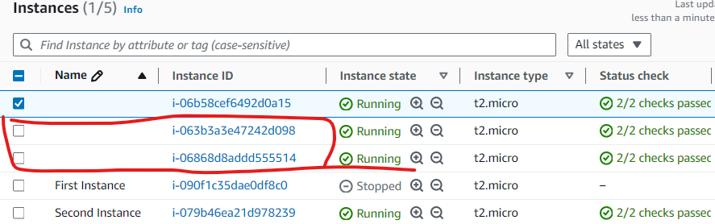
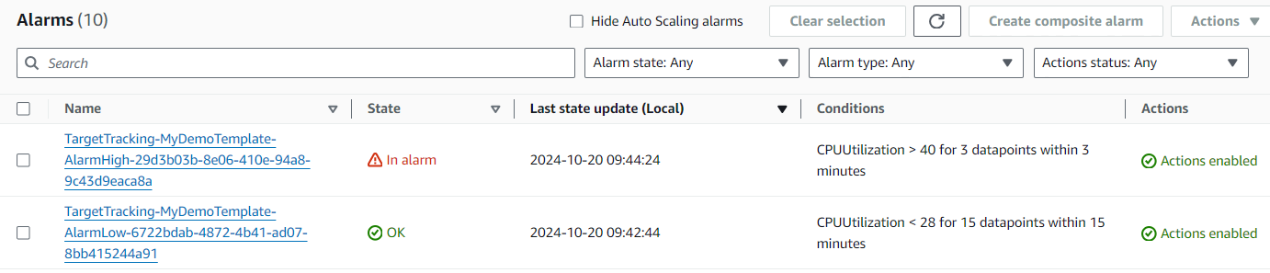
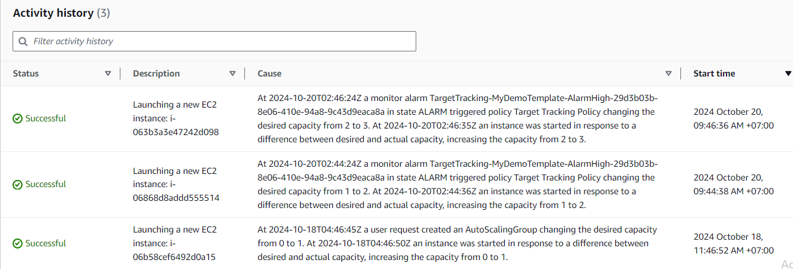
Finally you stop stress command by CTRL + C will decrease CPU Util percent and once it below 40% it will trigger an scale in operation to remove the instances that it created to scale out before.

QA
Only Network Load Balancer provides both static DNS name and static IP. While, Application Load Balancer provides a static DNS name but it does NOT provide a static IP. The reason being that AWS wants your Elastic Load Balancer to be accessible using a static endpoint, even if the underlying infrastructure that AWS manages changes.
Question 4:
You are running a website on 10 EC2 instances fronted by an Elastic Load Balancer. Your users are complaining about the fact that the website always asks them to re-authenticate when they are moving between website pages. You are puzzled because it's working just fine on your machine and in the Dev environment with 1 EC2 instance. What could be the reason?
Answer: ELB Sticky Session feature ensures traffic for the same client is always redirected to the same target (e.g., EC2 instance). This helps that the client does not lose his session data.
Question 5:
You are using an Application Load Balancer to distribute traffic to your website hosted on EC2 instances. It turns out that your website only sees traffic coming from private IPv4 addresses which are in fact your Application Load Balancer's IP addresses. What should you do to get the IP address of clients connected to your website?
Answer: When using an Application Load Balancer to distribute traffic to your EC2 instances, the IP address you'll receive requests from will be the ALB's private IP addresses. To get the client's IP address, ALB adds an additional header called "X-Forwarded-For" contains the client's IP address.
Question 6:
You hosted an application on a set of EC2 instances fronted by an Elastic Load Balancer. A week later, users begin complaining that sometimes the application just doesn't work. You investigate the issue and found that some EC2 instances crash from time to time. What should you do to protect users from connecting to the EC2 instances that are crashing?
Answer: When you enable ELB Health Checks, your ELB won't send traffic to unhealthy (crashed) EC2 instances.

Question 7:
You are working as a Solutions Architect for a company and you are required to design an architecture for a high-performance, low-latency application that will receive millions of requests per second. Which type of Elastic Load Balancer should you choose?
Answer: low-latency application that will receive millions of requests per second = Network Load Balancer
Explain: - NLB allows:
 Forward TCP & UDP traffic to your instances
 Handle millions of request per seconds
 Ultra-low latency
Question 8:
Application Load Balancers support the following protocols, EXCEPT:
Answer: ALB support HTTP, HTTPS, WebSocket Applications and DO NOT SUPPORT TCP protocol since it was Network protocol belong to Network Load Balancer
Question 9:
Application Load Balancers can route traffic to different Target Groups based on the following, EXCEPT:
ALB can route traffic to Target groups based on: Hostname, URL path, Source IP Address, HTTP Headers and Query Strings
And DO NOT based on Client’s location(Geography) that’s the physical server job
Question 10:
Registered targets in a Target Groups for an Application Load Balancer can be one of the following, EXCEPT:
Answer: Target Groups for ALB can be: EC2 instances, IP addresses, Lambda function, Application Load Balancer => So Network Load Balancer doesn’t belong here
Question 11:
For compliance purposes, you would like to expose a fixed static IP address to your end-users so that they can write firewall rules that will be stable and approved by regulators. What type of Elastic Load Balancer would you choose?
Answer: Network Load Balancer has one static IP address per AZ and you can attach an Elastic IP address to it. Application Load Balancers and Classic Load Balancers have a static DNS name.
Question 12:
You want to create a custom application-based cookie in your Application Load Balancer. Which of the following you can use as a cookie name?
Answer: The following cookie names are reserved by the ELB (AWSALB, AWSALBAPP, AWSALBTG).
Question 13:
You have a Network Load Balancer that distributes traffic across a set of EC2 instances in us-east-1. You have 2 EC2 instances in us-east-1b AZ and 5 EC2 instances in us-east-1e AZ. You have noticed that the CPU utilization is higher in the EC2 instances in us-east-1b AZ. After more investigation, you noticed that the traffic is equally distributed across the two AZs. How would you solve this problem?
Answer: Enable Cross-Zone Load Balancing since it distributes traffic to instances across all AZ you enabled Cross-Zone Load Balancing
When Cross-Zone Load Balancing is enabled, ELB distributes traffic evenly across all registered EC2 instances in all AZs.
Question 14:
Which feature in both Application Load Balancers and Network Load Balancers allows you to load multiple SSL certificates on one listener?
Answer: Server Name Indication (SNI) solve the problem of load multiple SSL certificates onto 1 server.

Question 15:
You have an Application Load Balancer that is configured to redirect traffic to 3 Target Groups based on the following hostnames: users.example.com, api.external.example.com, and checkout.example.com. You would like to configure HTTPS for each of these hostnames. How do you configure the ALB to make this work?
Answer: Server Name Indication (SNI) allows you to expose multiple HTTPS applications each with its own SSL certificate on the same listener. Read more here: https://aws.amazon.com/blogs/aws/new-application-load-balancer-sni/

Question 16:
You have an application hosted on a set of EC2 instances managed by an Auto Scaling Group that you configured both desired and maximum capacity to 3. Also, you have created a CloudWatch Alarm that is configured to scale out your ASG when CPU Utilization reaches 60%. Your application suddenly received huge traffic and is now running at 80% CPU Utilization. What will happen?
Answer: Nothing will happen since the design only allows to scale out max and desired capacity to 3.

Question 17:
You have an Auto Scaling Group fronted by an Application Load Balancer. You have configured the ASG to use ALB Health Checks, then one EC2 instance has just been reported unhealthy. What will happen to the EC2 instance?
Answer: You can configure the Auto Scaling Group to determine the EC2 instances' health based on Application Load Balancer Health Checks instead of EC2 Status Checks (default). When an EC2 instance fails the ALB Health Checks, it is marked unhealthy and will be terminated while the ASG launches a new EC2 instance.

Question 18:
Your boss asked you to scale your Auto Scaling Group based on the number of requests per minute your application makes to your database. What should you do?
Answer: There's no CloudWatch Metric for "requests per minute" for backend-to-database connections. You need to create a CloudWatch Custom Metric, then create a CloudWatch Alarm.
Guide on how to create AWS Cloud watch custom metric: How to create EC2 custom metrics with Amazon CloudWatch | TechTarget

Question 19:
An application is deployed with an Application Load Balancer and an Auto Scaling Group. Currently, you manually scale the ASG and you would like to define a Scaling Policy that will ensure the average number of connections to your EC2 instances is around 1000. Which Scaling Policy should you use?
Answer: Target Tracking Policy with option Application Load Balancer request count per target. Because this will count the active connections within per target group send to ALB
Question 20:
You have an ASG and a Network Load Balancer. The application on your ASG supports the HTTP protocol and is integrated with the Load Balancer health checks. You are currently using the TCP health checks. You would like to migrate to using HTTP health checks, what do you do?
Answer: Migrate the health check to HTTP because the NLB supports HTTP health checks as well as TCP and HTTPS
Question 21:
You have a website hosted in EC2 instances in an Auto Scaling Group fronted by an Application Load Balancer. Currently, the website is served over HTTP, and you have been tasked to configure it to use HTTPS. You have created a certificate in ACM and attached it to the Application Load Balancer. What you can do to force users to access the website using HTTPS instead of HTTP?
Answer: Edit your ALB Listener to redirect HTTP to HTTPS URL

